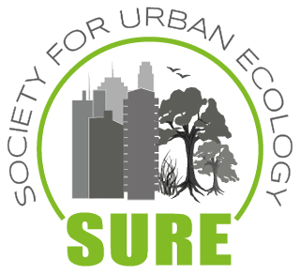
Information on open SURE internships

1) Home university/department of the internship (name, address):
Dept. Geography and Geology
University Salzburg
Hellbrunnerstr. 34
A 5020 Salzburg/Austria

2) Local supervisor of the internship (title, name, contact):
Univ.-Prof. Dr. Jürgen Breuste
Chair Urban and Landscape Ecology
juergen.breuste@sbg.ac.at
3) Possible internship period:
- March – May and May – July and July/August 2019
4) Minimum duration of the internship (in weeks):
- 8 weeks, optimal 12 weeks
5) Topic of the internship (e.g., project title):
- EU Project Sustainable Natural Resource Use in Arctic and High Mountainous Areas / SUNRAISE, Part: Urban development in mountain areas
- Summer School Urban + Mountains 2019 in Salzburg
- Urban biodiversity and ecosystem services

6) Tasks of the trainee (1-2 sentences):
Participation in the development of an international master curriculum (part) on ecological aspects of urbanizations and cities in mountains
Preparation and processing of a Summer School
- Development of projects in Salzburg and abroad on urban biodiversity and ecosystem services

7) Special requirements of the trainee (e.g., subject, "hard" and "soft skills"):
- Study and professional background: ecology, planning, landscape architecture, geography, biology, architecture or equivalent
- Organizational skills
8) Webpage of your department and if possible of the related project:
- www.urban-landscape-ecology.com/
9) Any further information you like to add regarding the internship:
Applicants should have a valid for Austria health insurance. Unfortunately there is no payment for the internship possible.
Please send the form back to the SURE Secretary-General Dr. Martina Artmann (m.artmann@ioer.de).
The offer will be posted at the SURE webpage (https://www.society-urban-ecology.org/).

